[](http://2.46.5.112:8004/website-webapp/common/preview_resource.action?id=ae2ae39e6eb5404089060d6e4da3d18a%26type=jpg%26jcrVer=1.0)  
  
[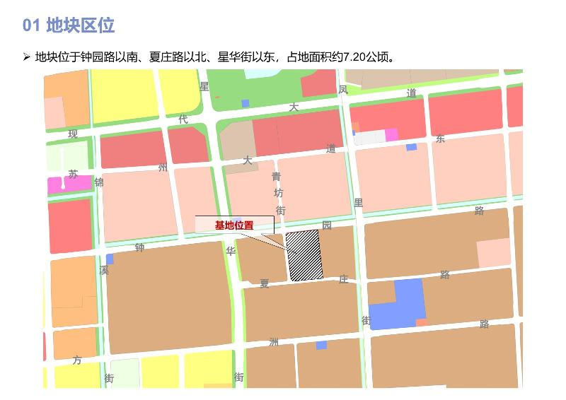](http://2.46.5.112:8004/website-webapp/common/preview_resource.action?id=d8a195fb723d47f1a0de8bc31c38738f%26type=jpg%26jcrVer=1.0)  
  
[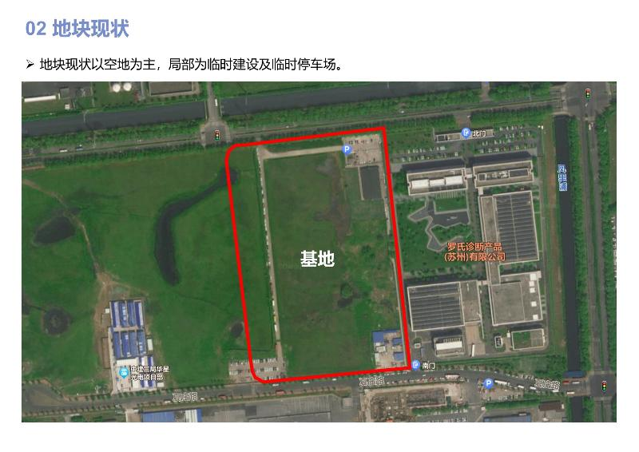](http://2.46.5.112:8004/website-webapp/common/preview_resource.action?id=d90ef96e11d14a87a84cfeffe296a511%26type=jpg%26jcrVer=1.0)  
  
[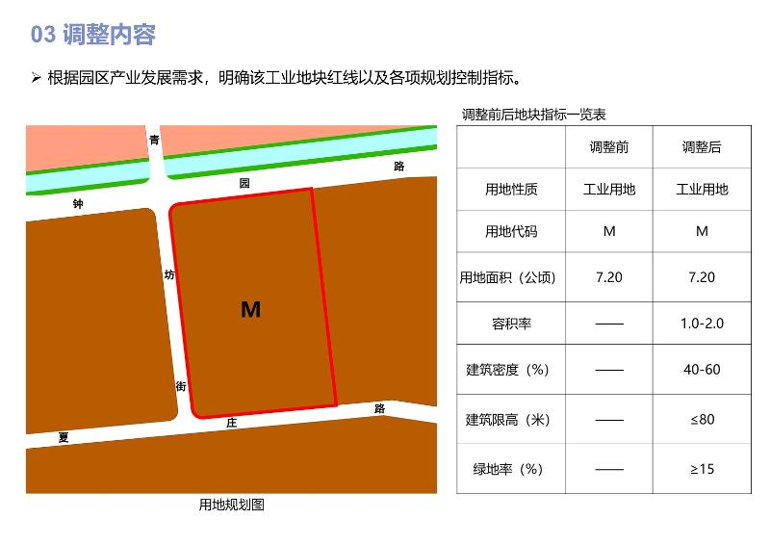](http://2.46.5.112:8004/website-webapp/common/preview_resource.action?id=92d983022674462f9dba97e1d75814d3%26type=jpg%26jcrVer=1.0)