[](http://2.46.5.112:8004/website-webapp/common/preview_resource.action?id=3b6621f7960e4c8ba580b0ca837abfcb%26type=jpg%26jcrVer=1.0)  
  
[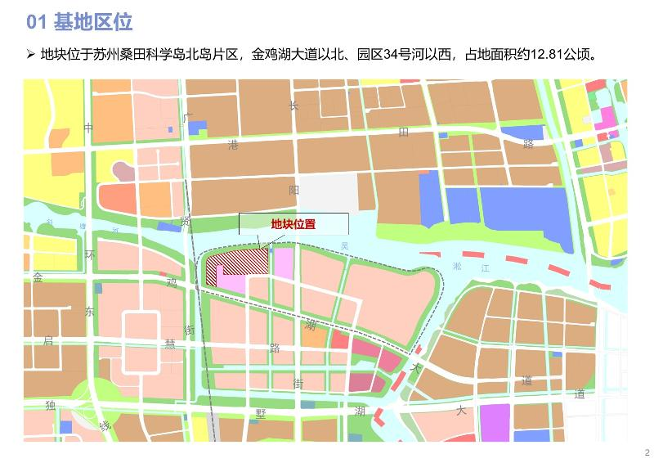](http://2.46.5.112:8004/website-webapp/common/preview_resource.action?id=90c1e21a6e1c493f921ab4c420325183%26type=jpg%26jcrVer=1.0)  
  
[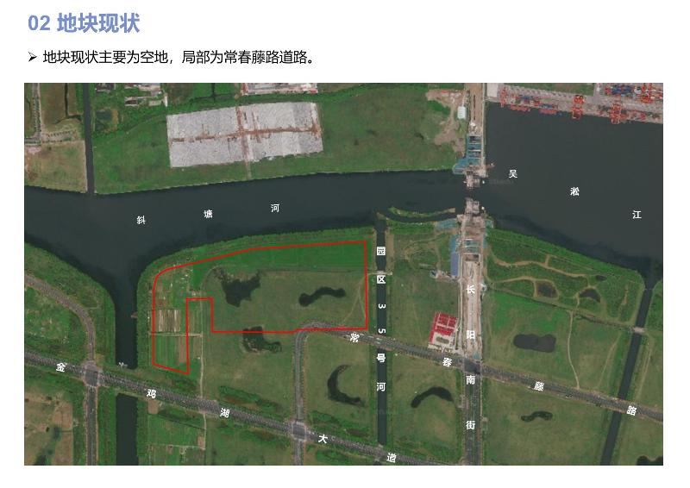](http://2.46.5.112:8004/website-webapp/common/preview_resource.action?id=ca6bacf27082409a881f17ed702675f0%26type=jpg%26jcrVer=1.0)  
  
[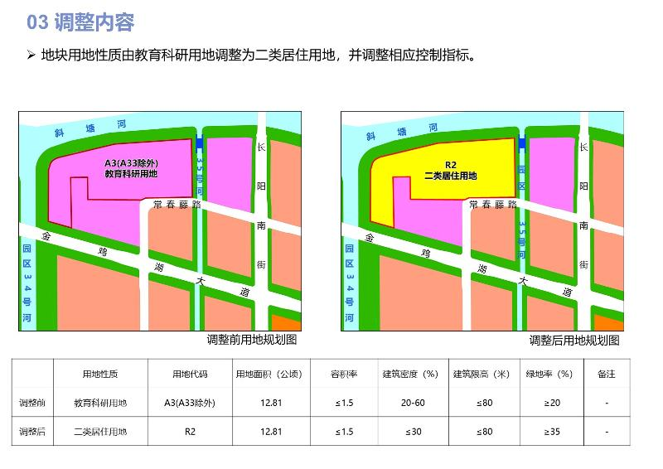](http://2.46.5.112:8004/website-webapp/common/preview_resource.action?id=1d78315652744dda993c2c28c8be9f8d%26type=jpg%26jcrVer=1.0)