[](http://2.46.5.112:8004/website-webapp/common/preview_resource.action?id=fc4b644a1dd44531a69178faf04eb2d7%26type=jpg%26jcrVer=1.0)  
  
[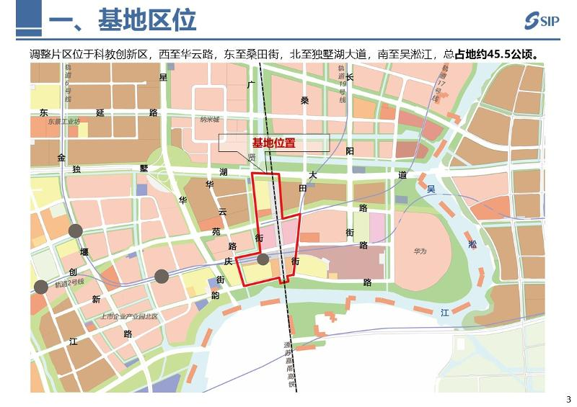](http://2.46.5.112:8004/website-webapp/common/preview_resource.action?id=50359251463b4ff3aad60cf4272d1eb4%26type=jpg%26jcrVer=1.0)  
  
[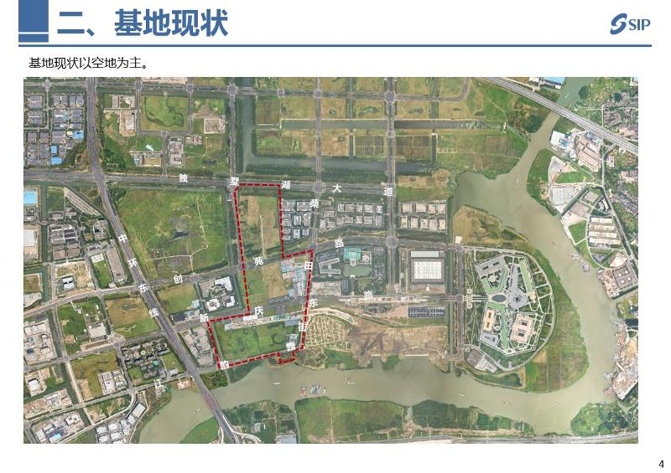](http://2.46.5.112:8004/website-webapp/common/preview_resource.action?id=f85987764fbc4a3a86838434c1c069fd%26type=jpg%26jcrVer=1.0)  
  
[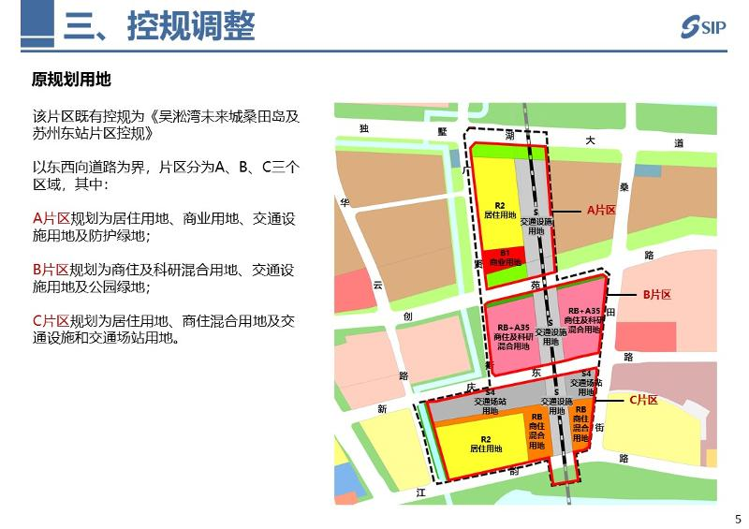](http://2.46.5.112:8004/website-webapp/common/preview_resource.action?id=d5d19af293c54f4fa0aae6dcb26ab7e1%26type=jpg%26jcrVer=1.0)  
  
[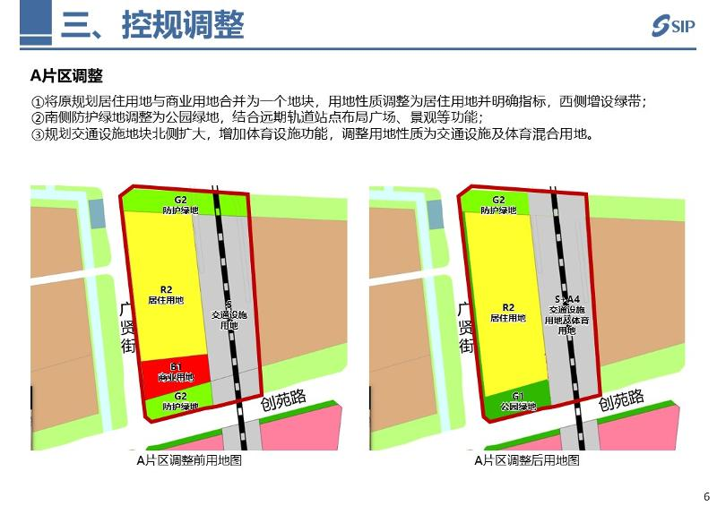](http://2.46.5.112:8004/website-webapp/common/preview_resource.action?id=0126e2408a4f44db954a17391f9e16eb%26type=jpg%26jcrVer=1.0)  
  
[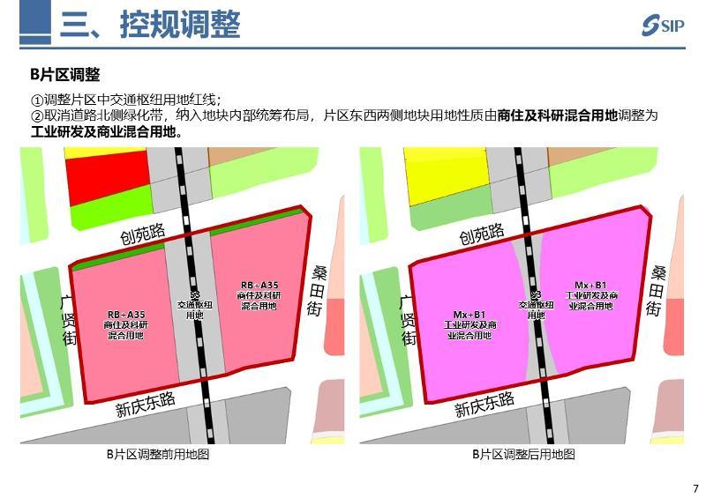](http://2.46.5.112:8004/website-webapp/common/preview_resource.action?id=0311f42ce36a47b2ba3eb85b1f234b11%26type=jpg%26jcrVer=1.0)  
  
[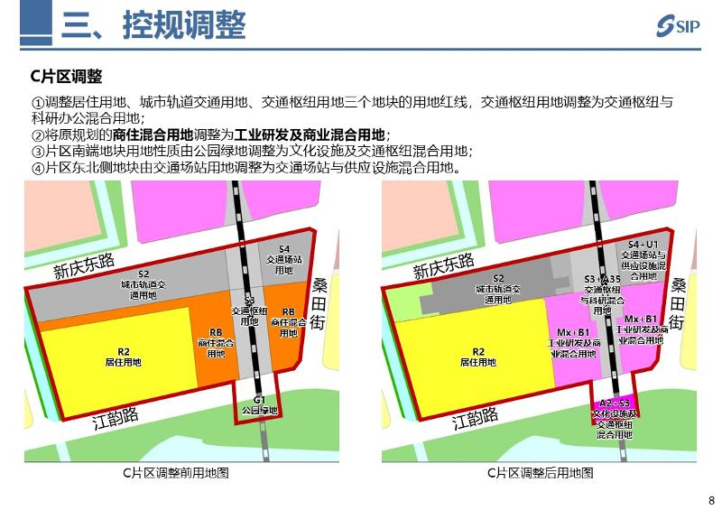](http://2.46.5.112:8004/website-webapp/common/preview_resource.action?id=0b5f5c4c778242eebe4f32e52b59539f%26type=jpg%26jcrVer=1.0)  
  
[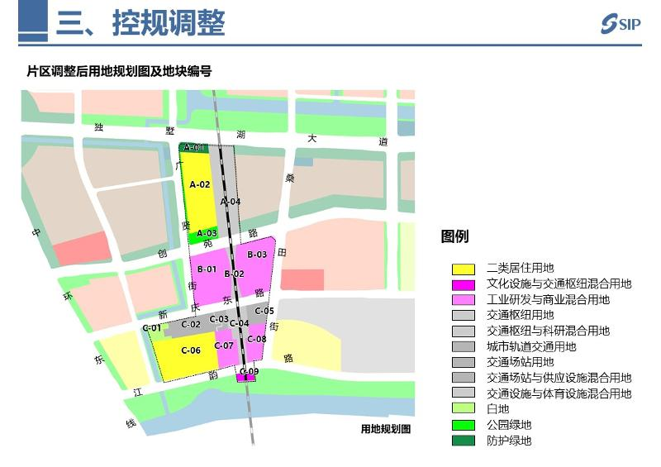](http://2.46.5.112:8004/website-webapp/common/preview_resource.action?id=a95edd540cf347d9907d76efccf1e191%26type=jpg%26jcrVer=1.0)  
  
[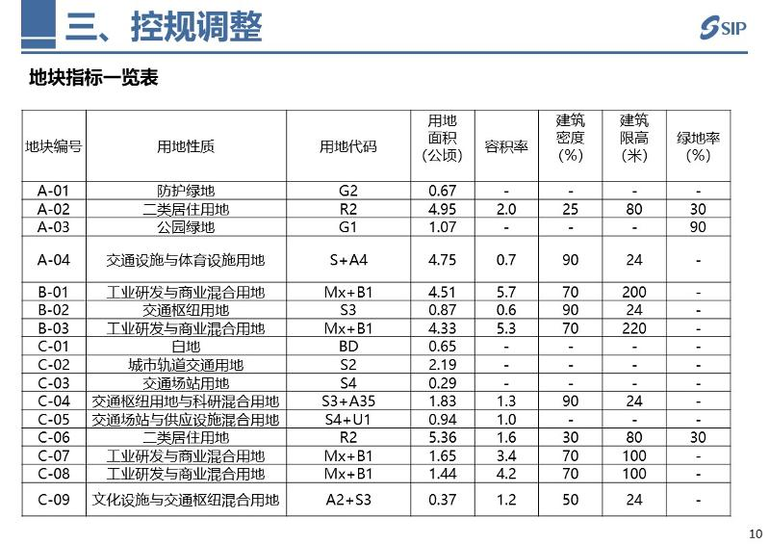](http://2.46.5.112:8004/website-webapp/common/preview_resource.action?id=1eea06f9d73a48c5891691d903e0db33%26type=jpg%26jcrVer=1.0)  
  
[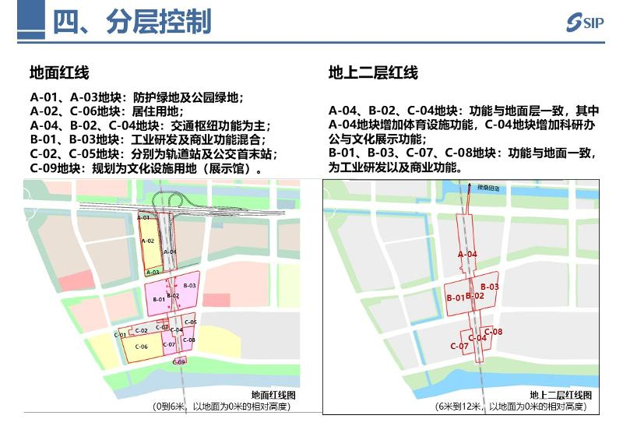](http://2.46.5.112:8004/website-webapp/common/preview_resource.action?id=9ede2548a5e54e50a15f8c43eb976bb2%26type=jpg%26jcrVer=1.0)  
  
[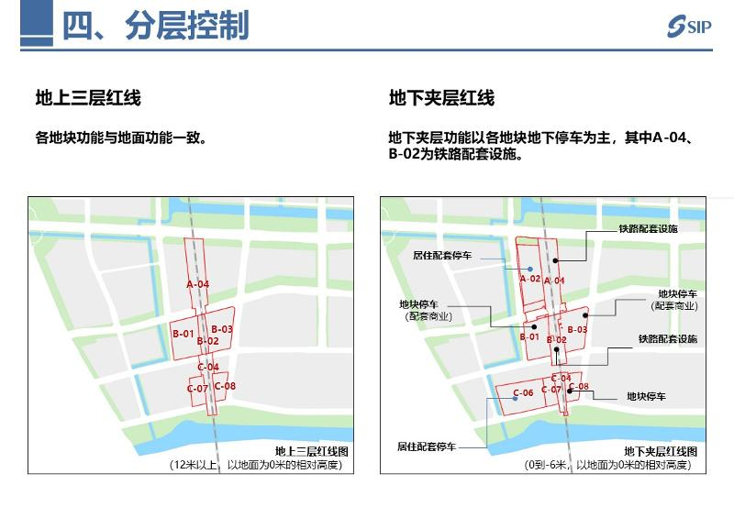](http://2.46.5.112:8004/website-webapp/common/preview_resource.action?id=9d8dadd80b934dfb892bd24f1521237a%26type=jpg%26jcrVer=1.0)  
  
[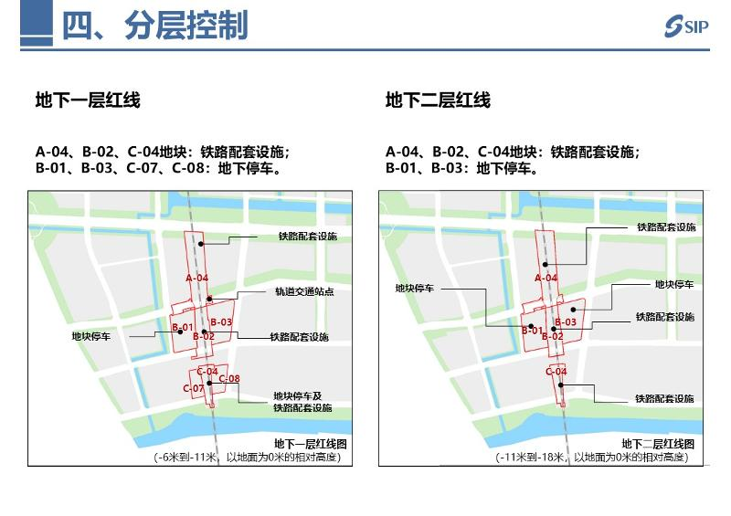](http://2.46.5.112:8004/website-webapp/common/preview_resource.action?id=090ea48ad9ce4e1fbe1019fb1f74a235%26type=jpg%26jcrVer=1.0)  
  
[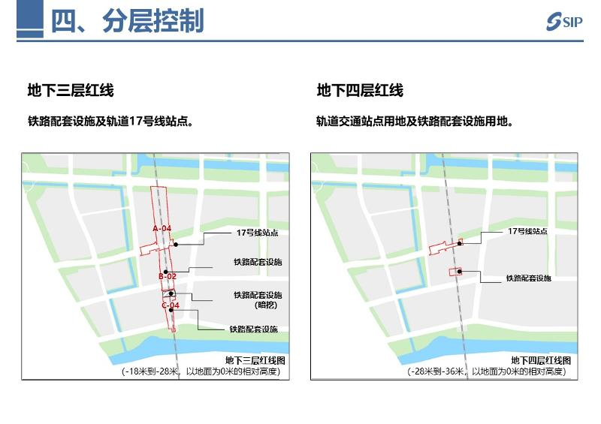](http://2.46.5.112:8004/website-webapp/common/preview_resource.action?id=7248b160dc874566bc2278fff9ffb580%26type=jpg%26jcrVer=1.0)  
  
[](http://2.46.5.112:8004/website-webapp/common/preview_resource.action?id=9362fadc022444e98870822169577b26%26type=jpg%26jcrVer=1.0)  
  
[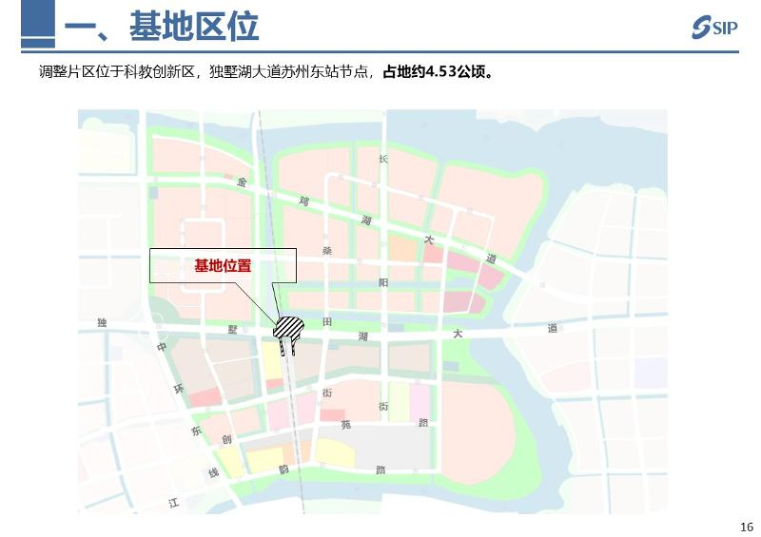](http://2.46.5.112:8004/website-webapp/common/preview_resource.action?id=56f0a542bdeb4df7bf273f62468ed989%26type=jpg%26jcrVer=1.0)  
  
[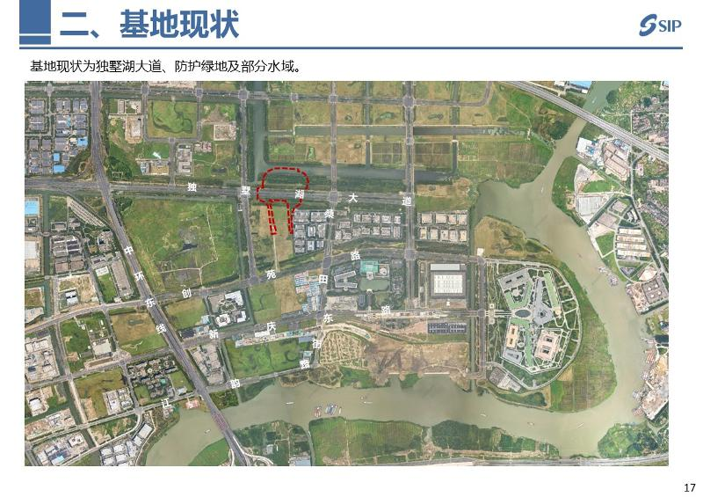](http://2.46.5.112:8004/website-webapp/common/preview_resource.action?id=2461305f0e0f4baaa90b7f654e8c295e%26type=jpg%26jcrVer=1.0)  
  
[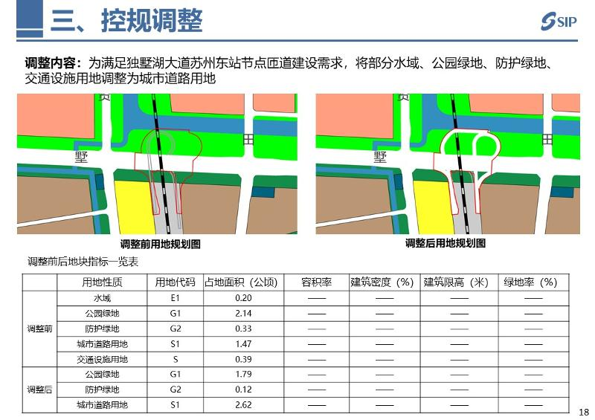](http://2.46.5.112:8004/website-webapp/common/preview_resource.action?id=6b3c1afaaebc438ea6c5db9f81d1572b%26type=jpg%26jcrVer=1.0)