[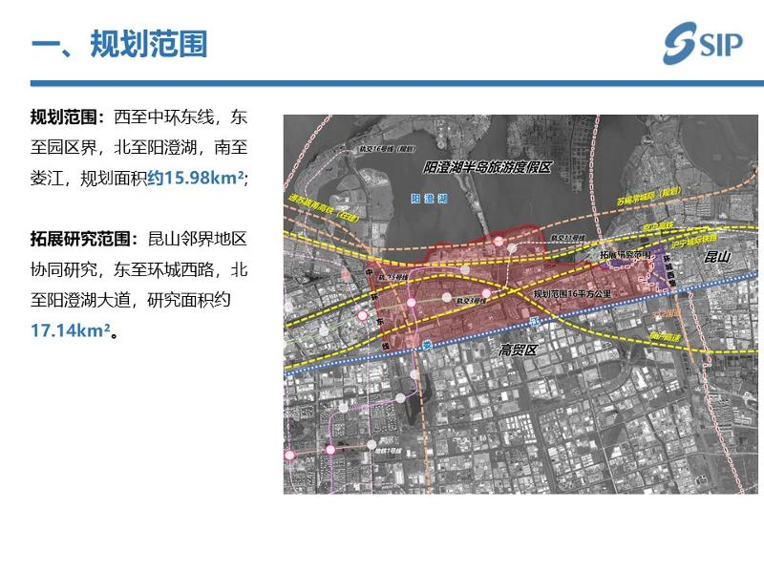](http://2.46.5.112:8004/website-webapp/common/preview_resource.action?id=f1e728334fc2405faf75434738ffa8c7%26type=jpg%26jcrVer=1.0)  
  
[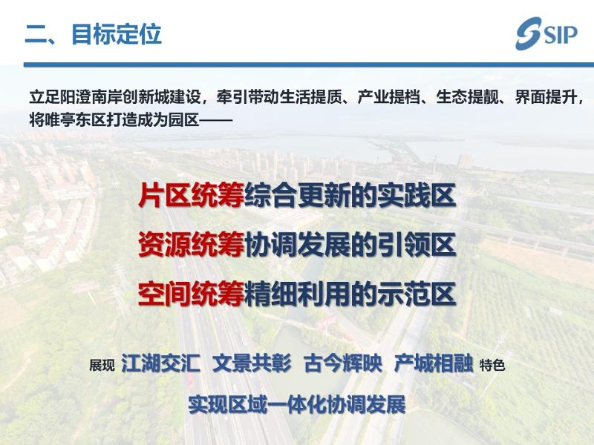](http://2.46.5.112:8004/website-webapp/common/preview_resource.action?id=1d7c0855aa474dff84888f56fe5fcc6b%26type=jpg%26jcrVer=1.0)  
  
[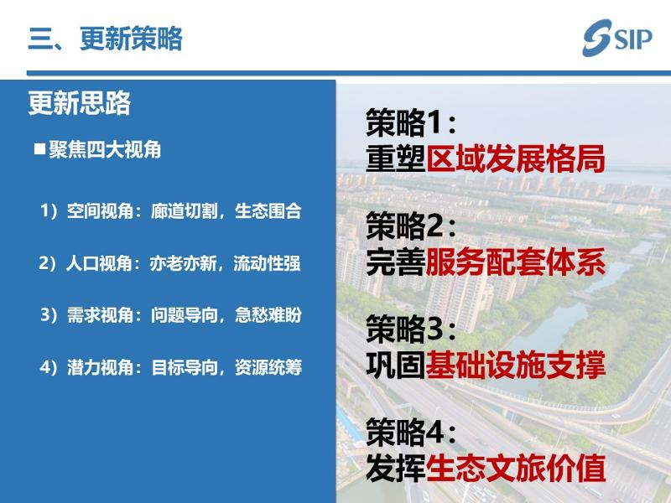](http://2.46.5.112:8004/website-webapp/common/preview_resource.action?id=75c6d305dc194acab7eb9d93f35b59c7%26type=jpg%26jcrVer=1.0)  
  
[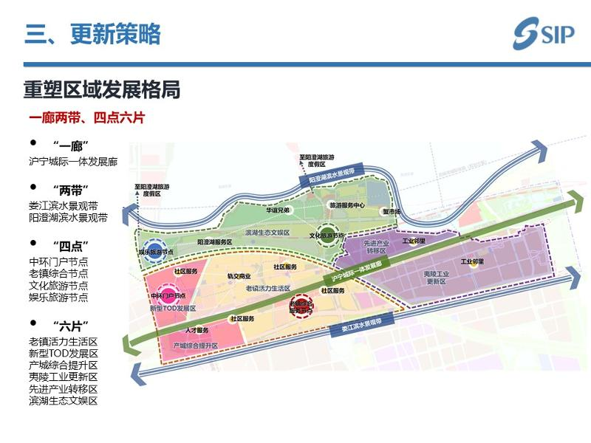](http://2.46.5.112:8004/website-webapp/common/preview_resource.action?id=fbfd22bd1d694d0e8b77ddfbd69e553c%26type=jpg%26jcrVer=1.0)  
  
[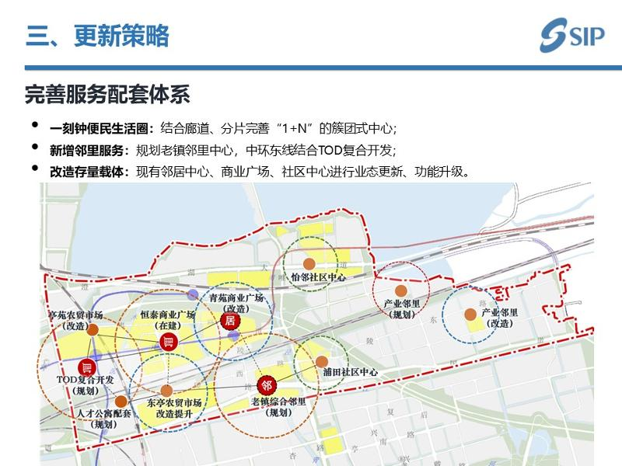](http://2.46.5.112:8004/website-webapp/common/preview_resource.action?id=fcea482dfb1645518e24b07af2771d56%26type=jpg%26jcrVer=1.0)  
  
[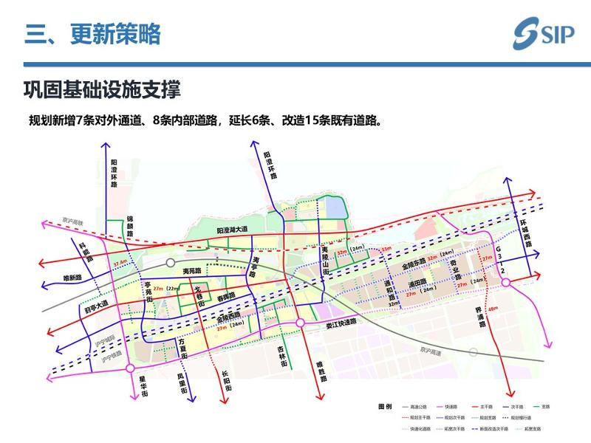](http://2.46.5.112:8004/website-webapp/common/preview_resource.action?id=97da89f0ab874ac2a7d75033d2248474%26type=jpg%26jcrVer=1.0)  
  
[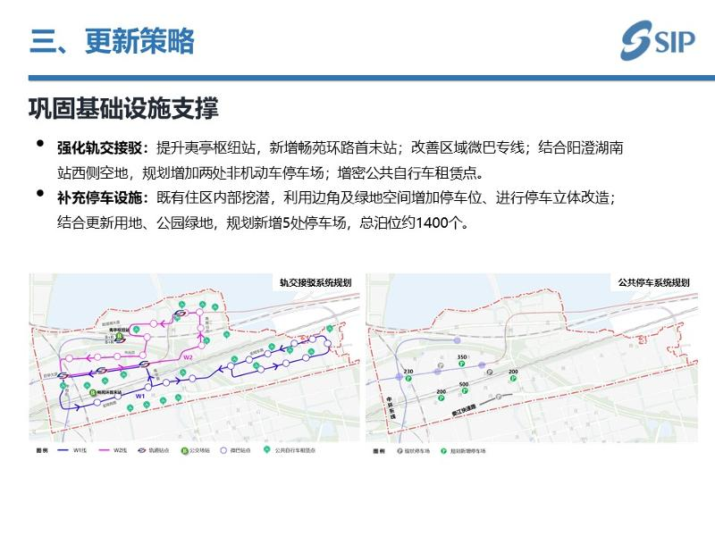](http://2.46.5.112:8004/website-webapp/common/preview_resource.action?id=1f55081381a841ea89bb55969efaff90%26type=jpg%26jcrVer=1.0)  
  
[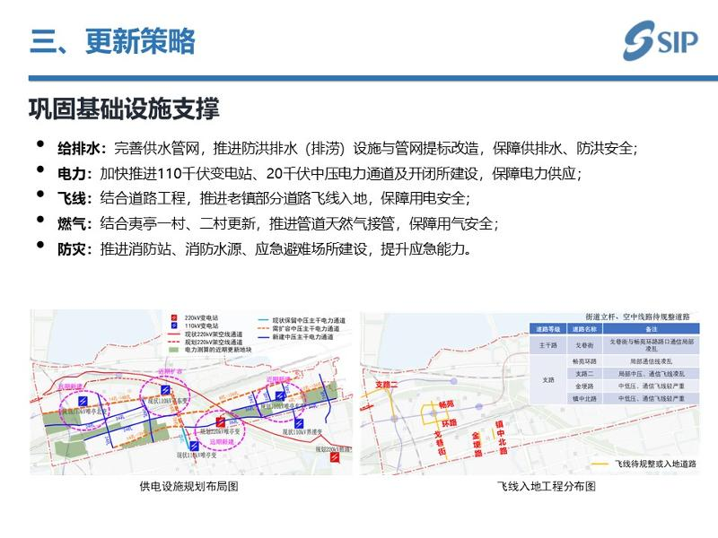](http://2.46.5.112:8004/website-webapp/common/preview_resource.action?id=a6f38c9da9a7419fa904d6642134fdc3%26type=jpg%26jcrVer=1.0)  
  
[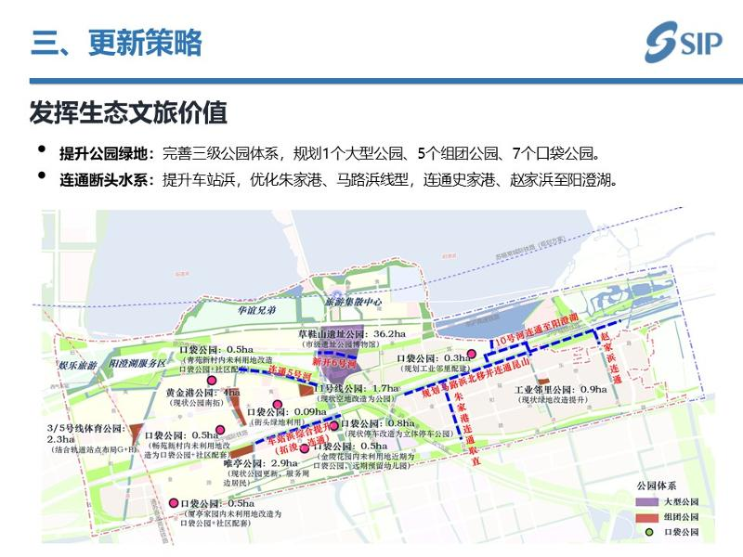](http://2.46.5.112:8004/website-webapp/common/preview_resource.action?id=9877d81e4ec347e4b142fef1dd769536%26type=jpg%26jcrVer=1.0)  
  
[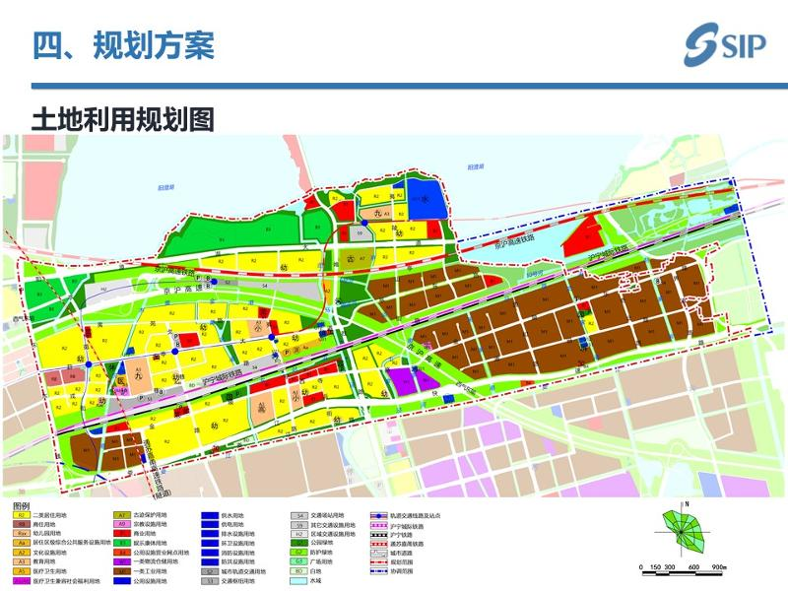](http://2.46.5.112:8004/website-webapp/common/preview_resource.action?id=72d9687bea6a47a98dab3cd1ab8331a9%26type=jpg%26jcrVer=1.0)  
  
[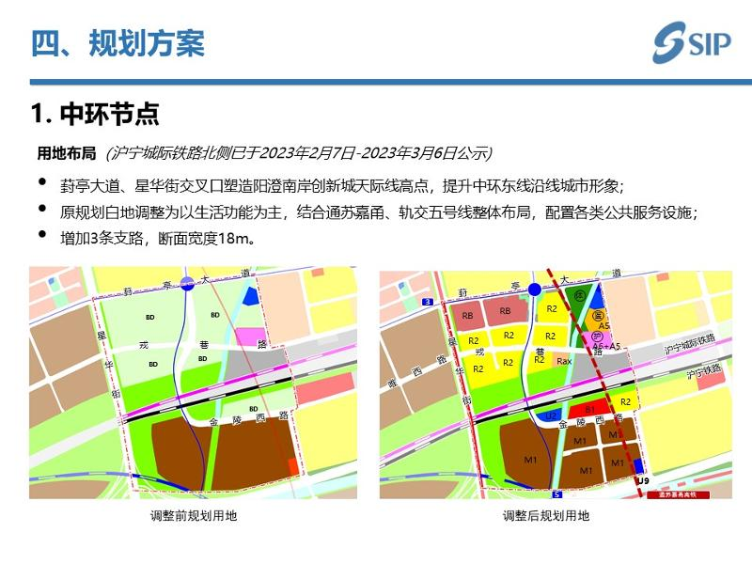](http://2.46.5.112:8004/website-webapp/common/preview_resource.action?id=4d3b3640ccf64c059dd766d1a071c1d7%26type=jpg%26jcrVer=1.0)  
  
[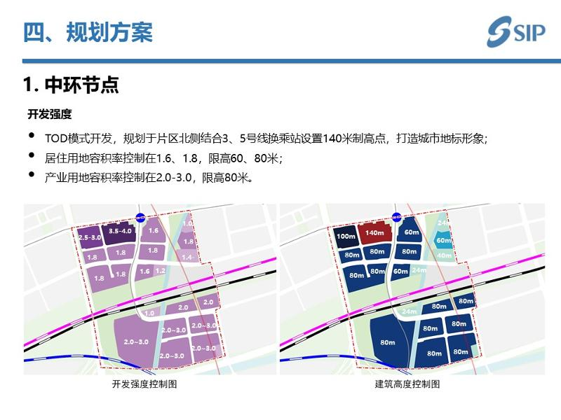](http://2.46.5.112:8004/website-webapp/common/preview_resource.action?id=ff6140cbaba648c9b1517f6399715bcd%26type=jpg%26jcrVer=1.0)  
  
[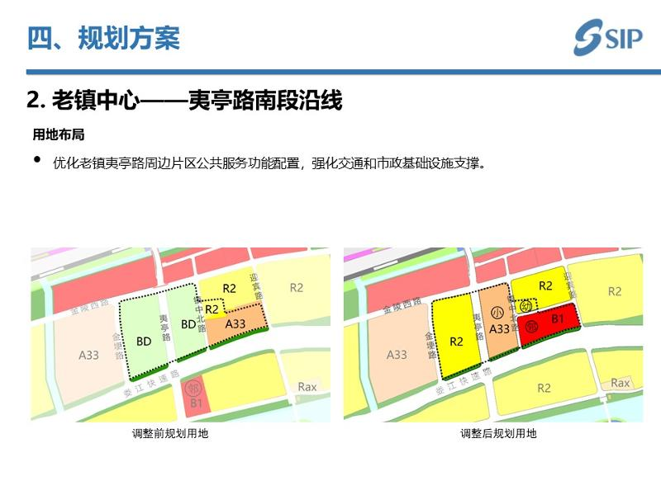](http://2.46.5.112:8004/website-webapp/common/preview_resource.action?id=899c29400f5a4c0a8082e28757f4fdf4%26type=jpg%26jcrVer=1.0)  
  
[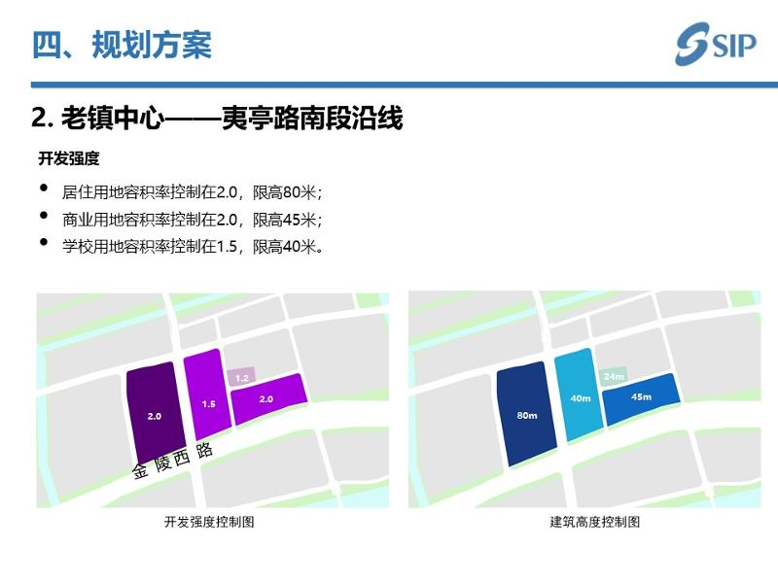](http://2.46.5.112:8004/website-webapp/common/preview_resource.action?id=a6e7e4801e6749d09d7ae98ef65a1a08%26type=jpg%26jcrVer=1.0)  
  
[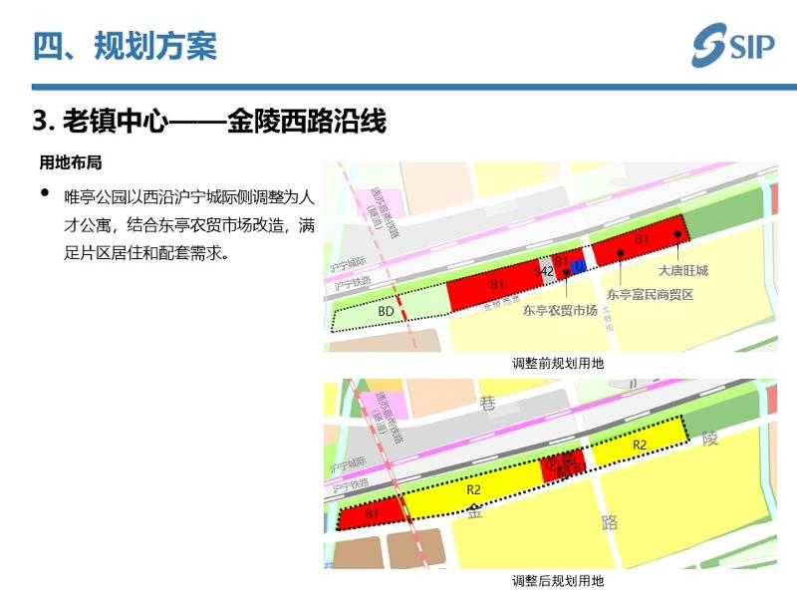](http://2.46.5.112:8004/website-webapp/common/preview_resource.action?id=8dae19cbde924070ace86f07d7b8f5e5%26type=jpg%26jcrVer=1.0)  
  
[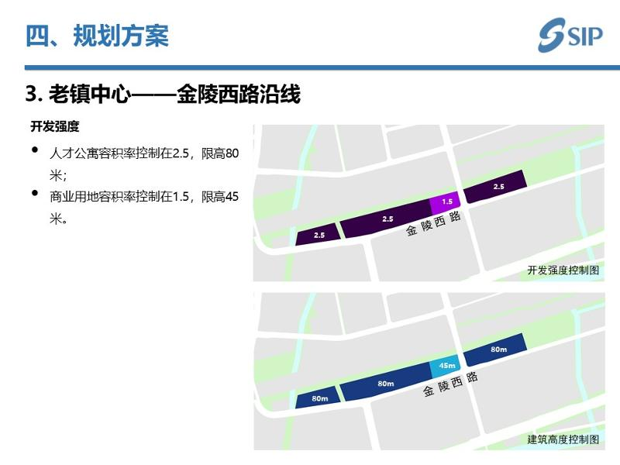](http://2.46.5.112:8004/website-webapp/common/preview_resource.action?id=7dbb9badaf4e4edf808d5bb140567f2f%26type=jpg%26jcrVer=1.0)  
  
[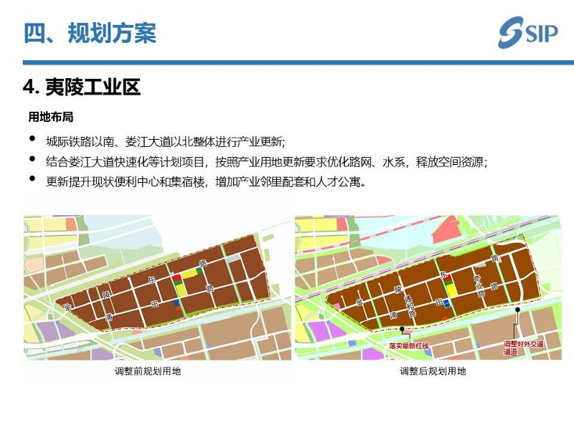](http://2.46.5.112:8004/website-webapp/common/preview_resource.action?id=f28ff5c87217454ca59dc7ed0ab4c584%26type=jpg%26jcrVer=1.0)  
  
[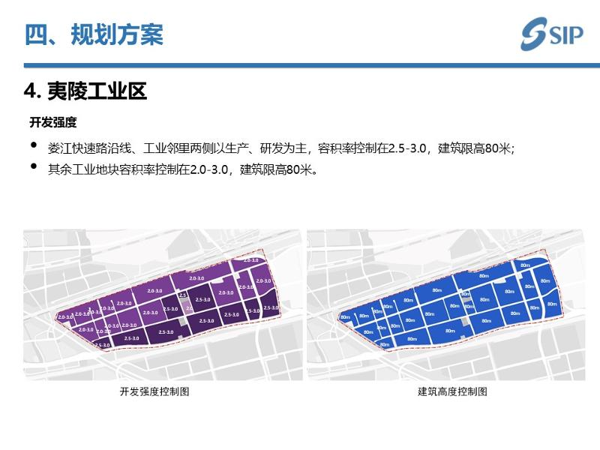](http://2.46.5.112:8004/website-webapp/common/preview_resource.action?id=16daaeecd59f405ba4876ddb70b549c0%26type=jpg%26jcrVer=1.0)