  
  
[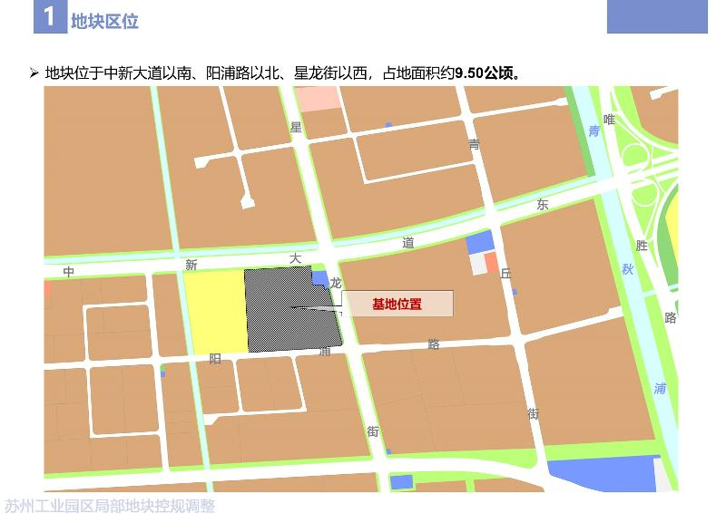](http://2.46.5.112:8004/website-webapp/common/preview_resource.action?id=b8b2ec9235a048a4836da97985783218%26type=jpg%26jcrVer=1.0)  
  
[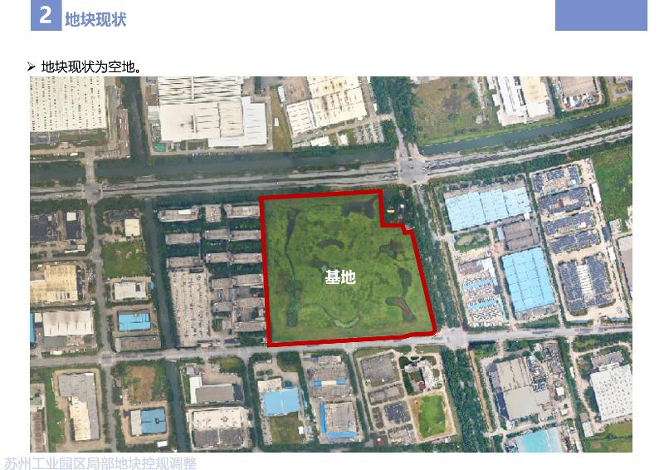](http://2.46.5.112:8004/website-webapp/common/preview_resource.action?id=6cd5da359f6c40be960ee45520ba6654%26type=jpg%26jcrVer=1.0)  
  
[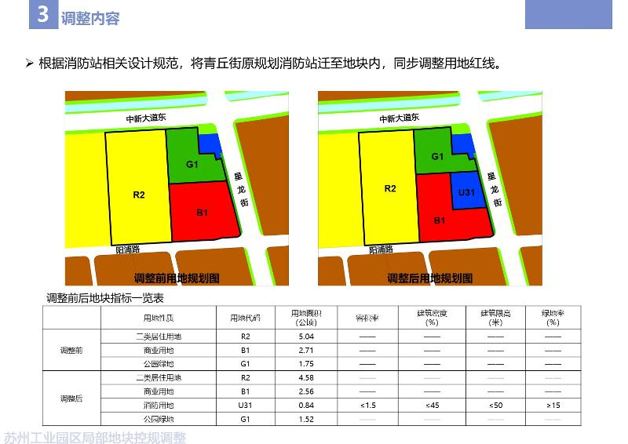](http://2.46.5.112:8004/website-webapp/common/preview_resource.action?id=c1821bf7c7f7470685be7be72df3bfaa%26type=jpg%26jcrVer=1.0)  
  
  
  
[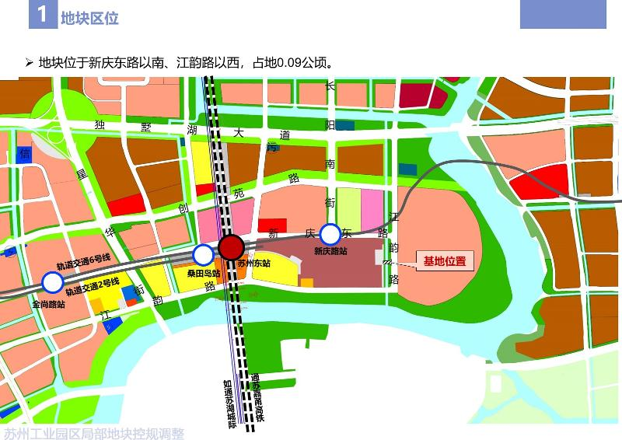](http://2.46.5.112:8004/website-webapp/common/preview_resource.action?id=7dc44a64d5aa412bb269551094a458d0%26type=jpg%26jcrVer=1.0)  
  
[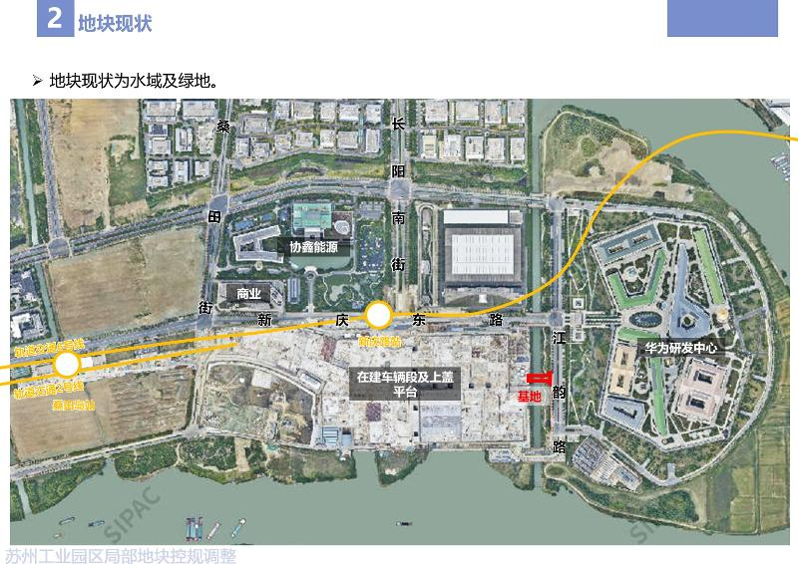](http://2.46.5.112:8004/website-webapp/common/preview_resource.action?id=1068e585607f46daaec05aa38643ca07%26type=jpg%26jcrVer=1.0)  
  
[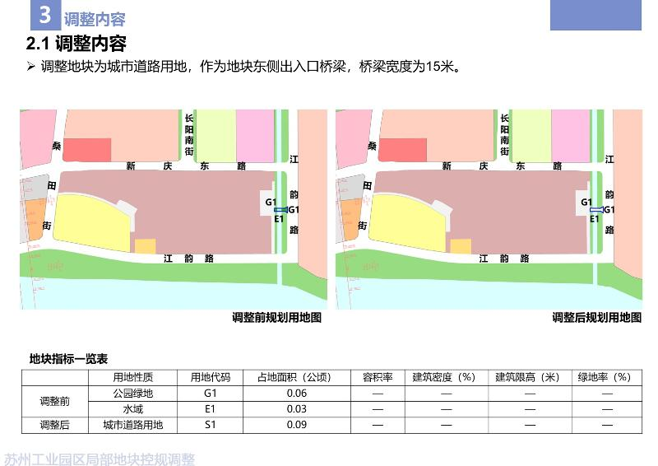](http://2.46.5.112:8004/website-webapp/common/preview_resource.action?id=16b0c51e44f945e1a17acf68ca5ac242%26type=jpg%26jcrVer=1.0)  
  
  
  
[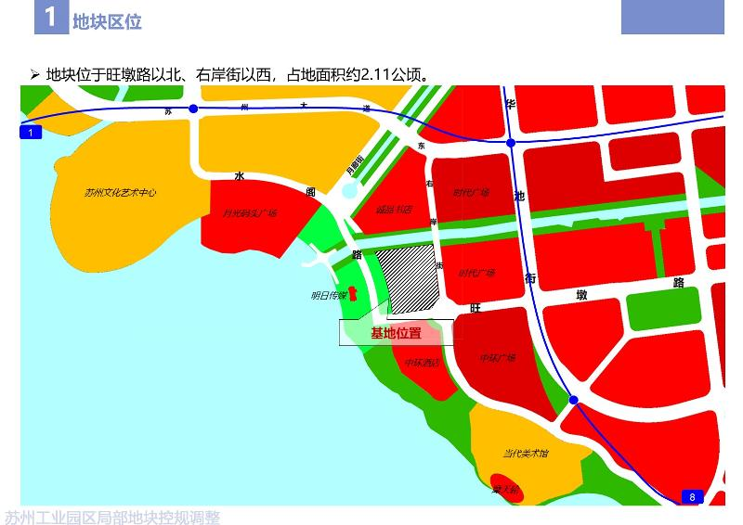](http://2.46.5.112:8004/website-webapp/common/preview_resource.action?id=6877e13bffb04360bb928e7d30169d95%26type=jpg%26jcrVer=1.0)  
  
[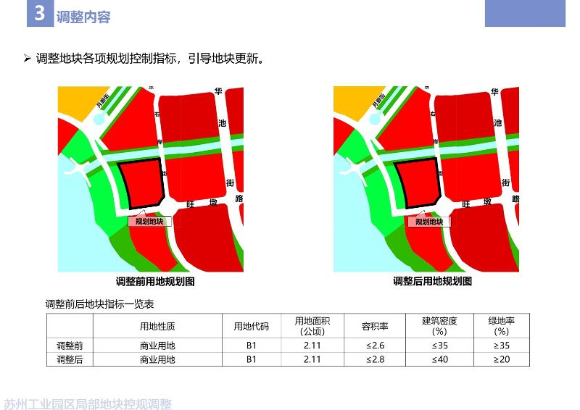](http://2.46.5.112:8004/website-webapp/common/preview_resource.action?id=745a7a726df04f4fa144f962023096ae%26type=jpg%26jcrVer=1.0)  
  
  
  
[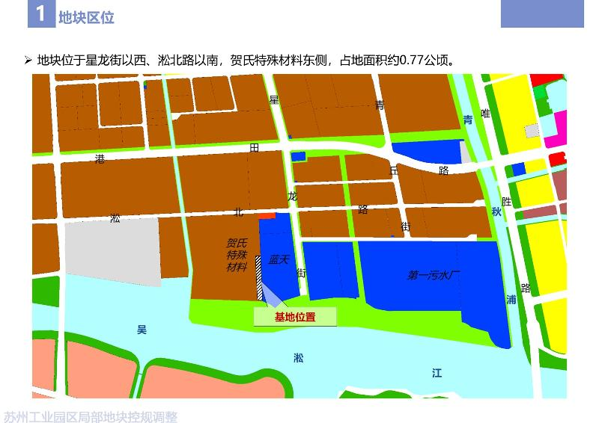](http://2.46.5.112:8004/website-webapp/common/preview_resource.action?id=72fef3c3cbe146968df724848505e9e4%26type=jpg%26jcrVer=1.0)  
  
[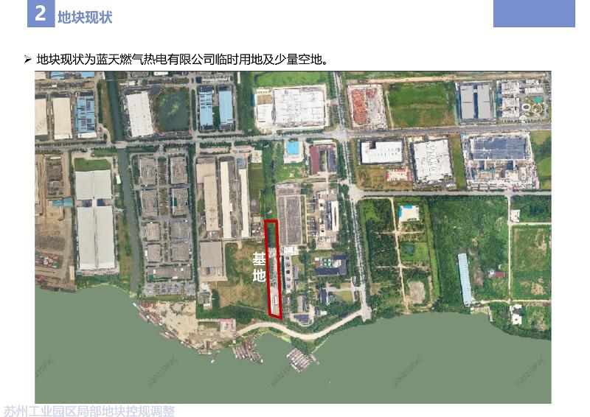](http://2.46.5.112:8004/website-webapp/common/preview_resource.action?id=72163b79cfec403cb090117f07617fda%26type=jpg%26jcrVer=1.0)  
  
[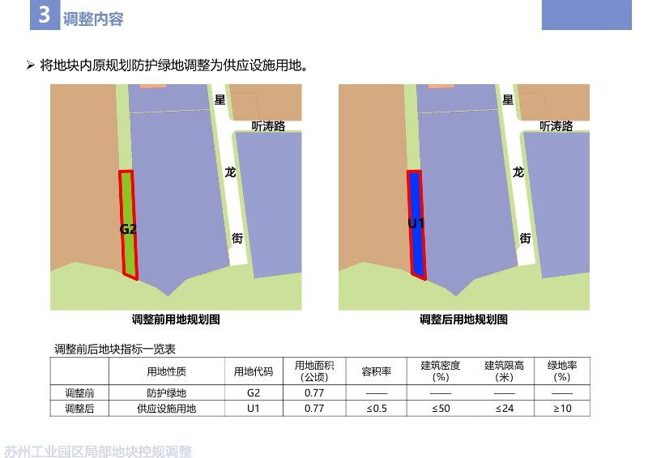](http://2.46.5.112:8004/website-webapp/common/preview_resource.action?id=e73e6e14670a432a8c68e8905509536a%26type=jpg%26jcrVer=1.0)