[](http://2.46.5.112:8004/website-webapp/common/preview_resource.action?id=864594534a464da8849981f19bf28ab6%26type=jpg%26jcrVer=1.0)  
  
[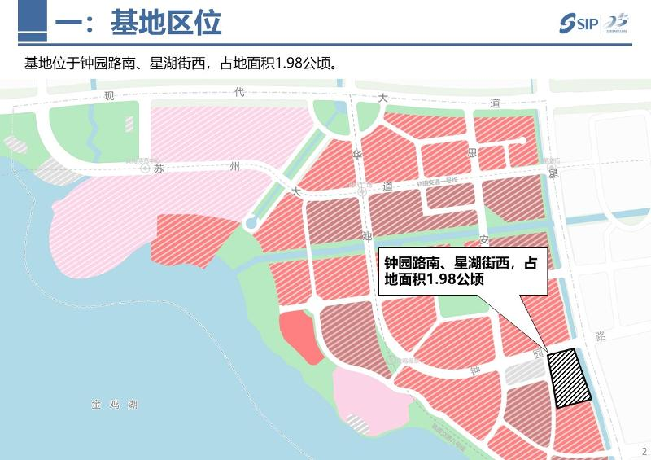](http://2.46.5.112:8004/website-webapp/common/preview_resource.action?id=8527ec1a12b44640877945120111f4e1%26type=jpg%26jcrVer=1.0)  
  
[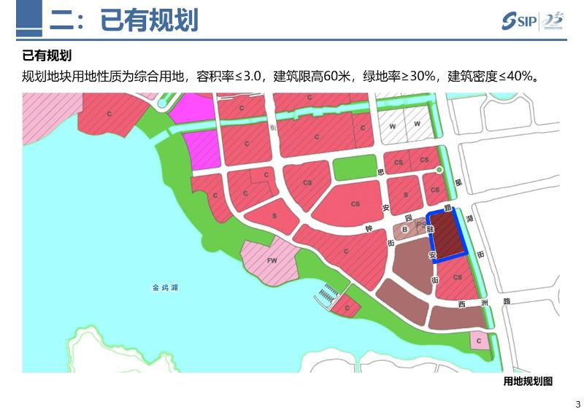](http://2.46.5.112:8004/website-webapp/common/preview_resource.action?id=e533ffb4d5524eba9714bfa09fa635a3%26type=jpg%26jcrVer=1.0)  
  
[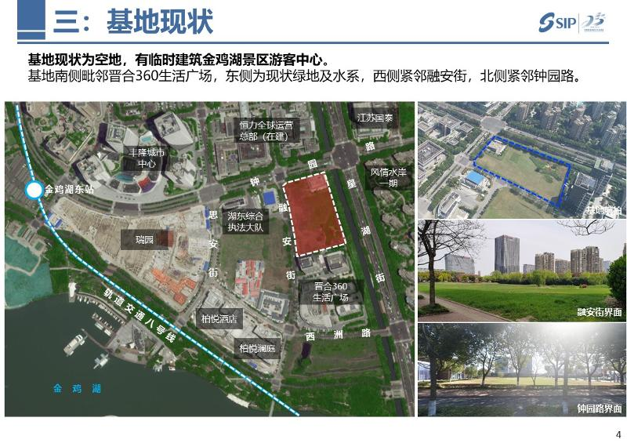](http://2.46.5.112:8004/website-webapp/common/preview_resource.action?id=968dbdd4b7e946f5a1e92238d8f89bc7%26type=jpg%26jcrVer=1.0)  
  
[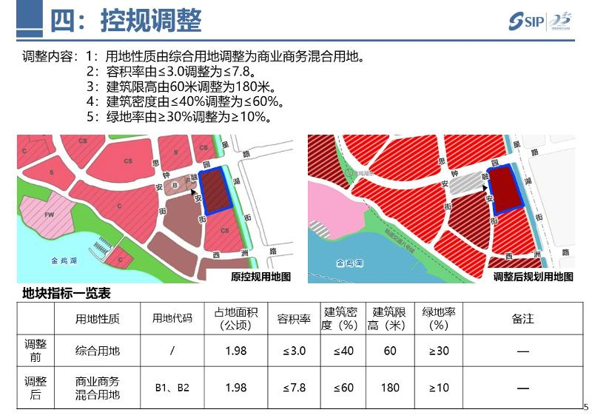](http://2.46.5.112:8004/website-webapp/common/preview_resource.action?id=3630cae4b90c42669d88d2fdbf09cb51%26type=jpg%26jcrVer=1.0)