[](http://2.46.5.112:8004/website-webapp/common/preview_resource.action?id=d3c64c97c8b54a75a636194f2eab421a%26type=jpg%26jcrVer=1.0)  
  
[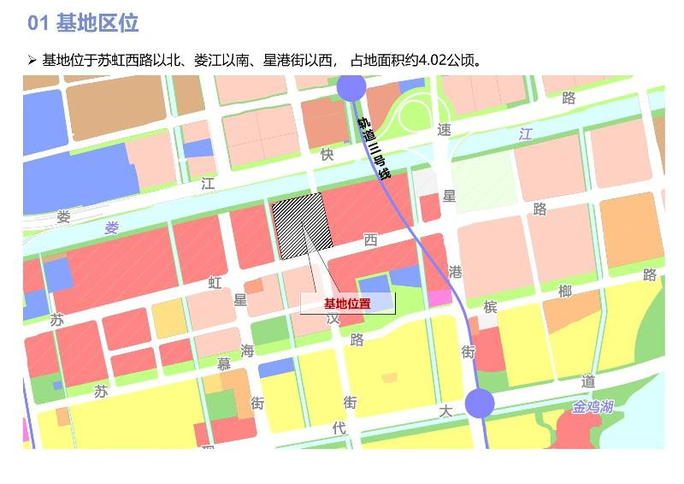](http://2.46.5.112:8004/website-webapp/common/preview_resource.action?id=c01ac0ce4bc44072b9f4cc6849355026%26type=jpg%26jcrVer=1.0)  
  
[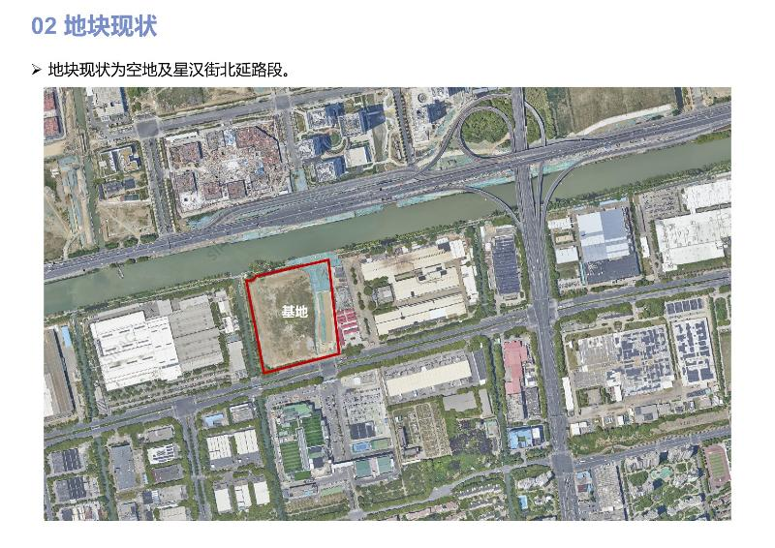](http://2.46.5.112:8004/website-webapp/common/preview_resource.action?id=17666b4694f54bdb8186f9623650e4ee%26type=jpg%26jcrVer=1.0)  
  
[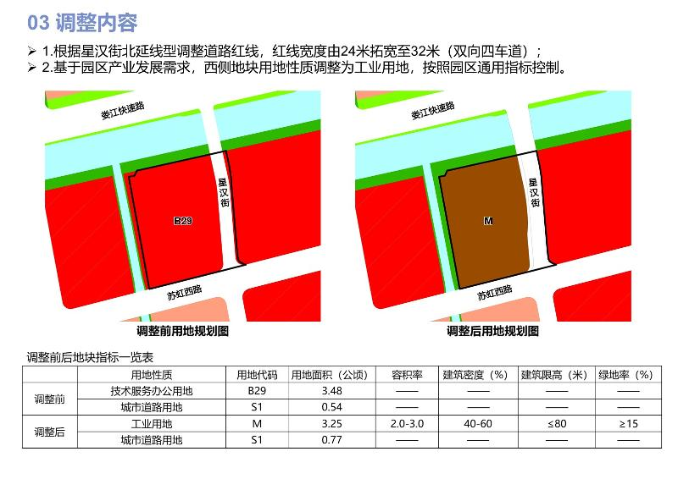](http://2.46.5.112:8004/website-webapp/common/preview_resource.action?id=03d371d5d00440fb85ebe306b9bbd816%26type=jpg%26jcrVer=1.0)