[](http://2.46.5.112:8004/website-webapp/common/preview_resource.action?id=c4ff361c5488405b920fa611b00fb3d3%26type=jpg%26jcrVer=1.0)  
  
[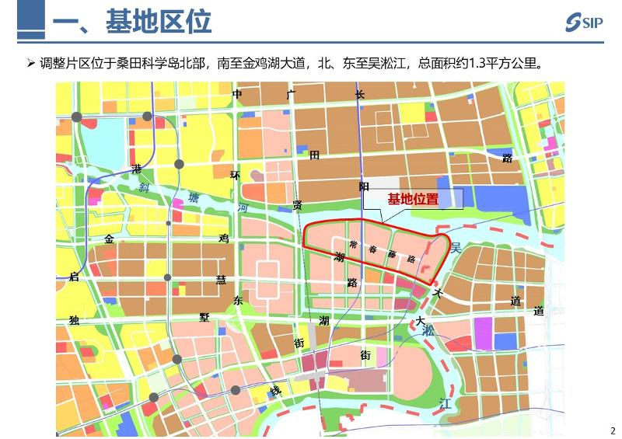](http://2.46.5.112:8004/website-webapp/common/preview_resource.action?id=c66334e1bd4245d7986fea7855f0536d%26type=jpg%26jcrVer=1.0)  
  
[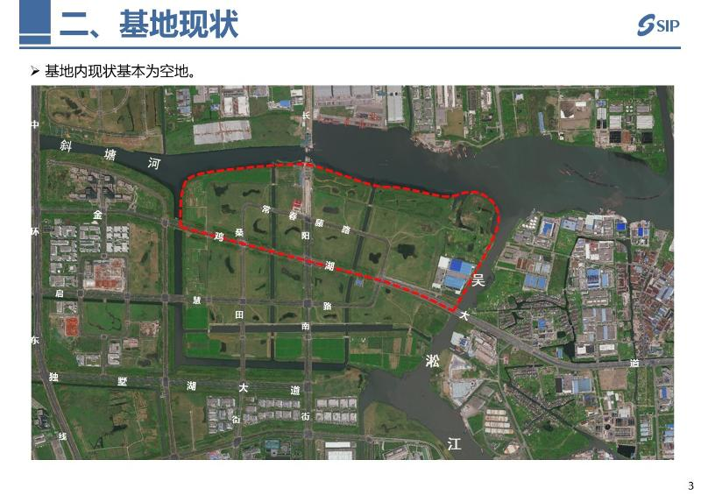](http://2.46.5.112:8004/website-webapp/common/preview_resource.action?id=5dd769bc7b9643548a3a98ff6d3ec84b%26type=jpg%26jcrVer=1.0)  
  
[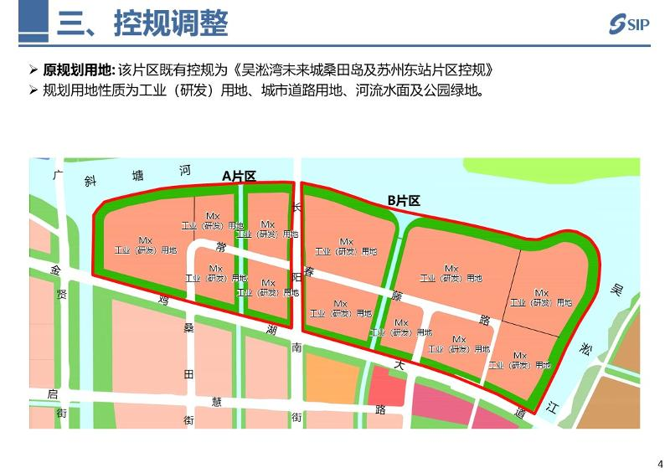](http://2.46.5.112:8004/website-webapp/common/preview_resource.action?id=9b6e8bce4cd8401a9f2fd18e2db88a47%26type=jpg%26jcrVer=1.0)  
  
[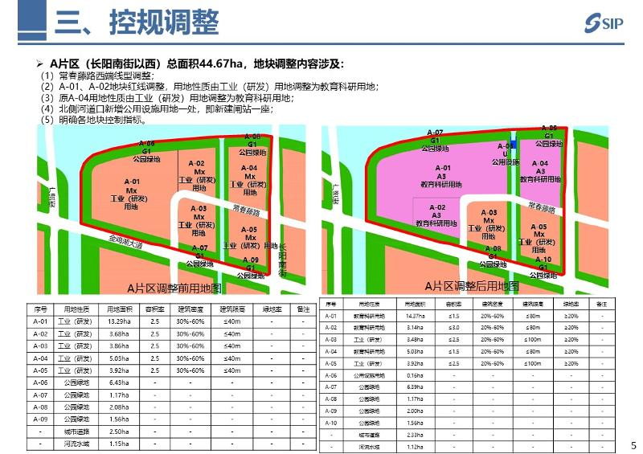](http://2.46.5.112:8004/website-webapp/common/preview_resource.action?id=94b14d3708794c4fa9330b4ce91ef209%26type=jpg%26jcrVer=1.0)  
  
[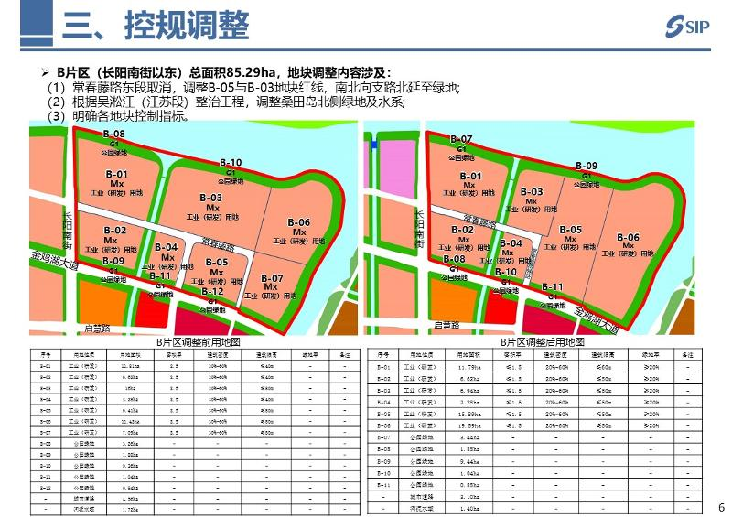](http://2.46.5.112:8004/website-webapp/common/preview_resource.action?id=dd0760e596544f04b9cedfc95760ed87%26type=jpg%26jcrVer=1.0)  
  
[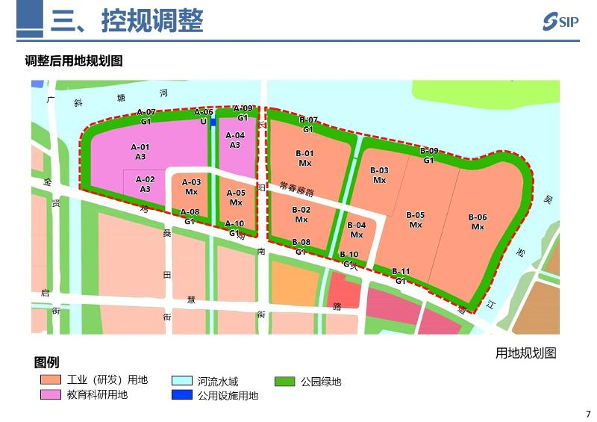](http://2.46.5.112:8004/website-webapp/common/preview_resource.action?id=7a6f9fdb8c7e4438a709771194d6376b%26type=jpg%26jcrVer=1.0)  
  
[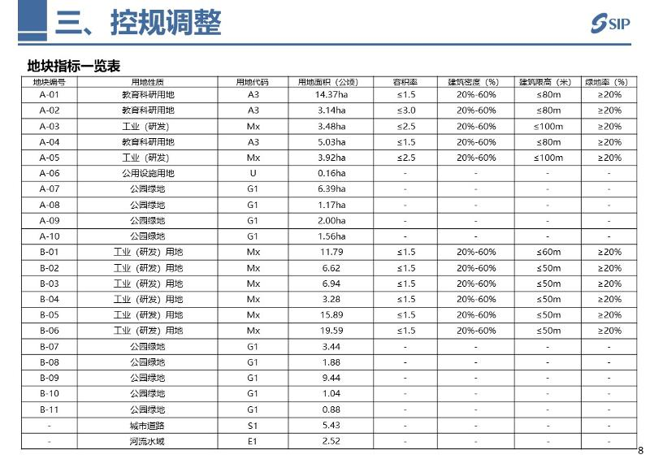](http://2.46.5.112:8004/website-webapp/common/preview_resource.action?id=614ddaa9bef443a0aa787d37de2b5b04%26type=jpg%26jcrVer=1.0)