  
  
[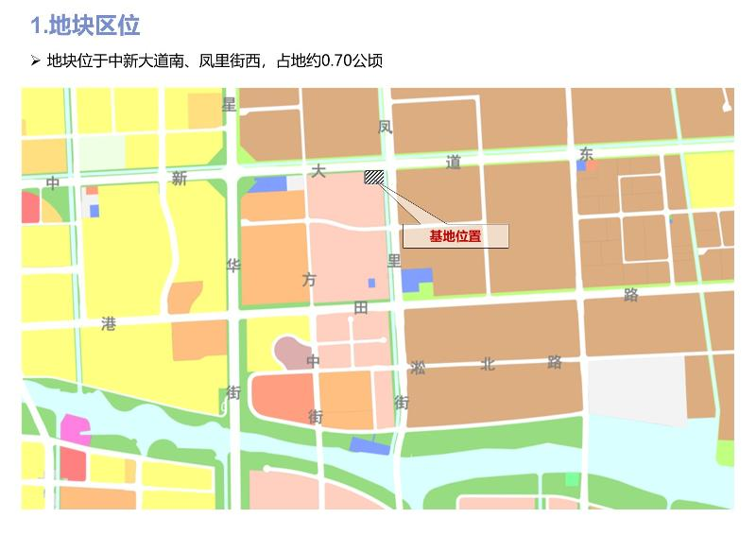](http://2.46.5.112:8004/website-webapp/common/preview_resource.action?id=ace13ebd959e4700b930efc168dbd5c4%26type=jpg%26jcrVer=1.0)  
  
[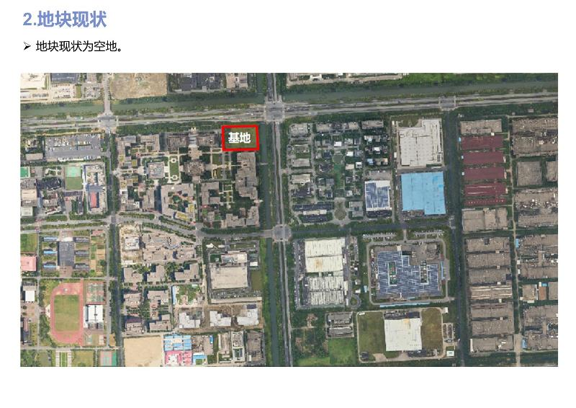](http://2.46.5.112:8004/website-webapp/common/preview_resource.action?id=53b81bd7d51243c8a16caa309cda8b21%26type=jpg%26jcrVer=1.0)  
  
[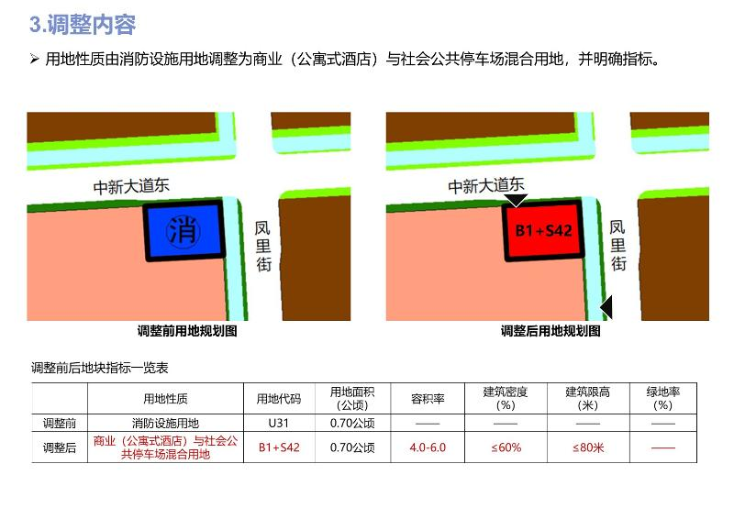](http://2.46.5.112:8004/website-webapp/common/preview_resource.action?id=3ba03dce1b784f15a27aa850d6e78c02%26type=jpg%26jcrVer=1.0)  
  
[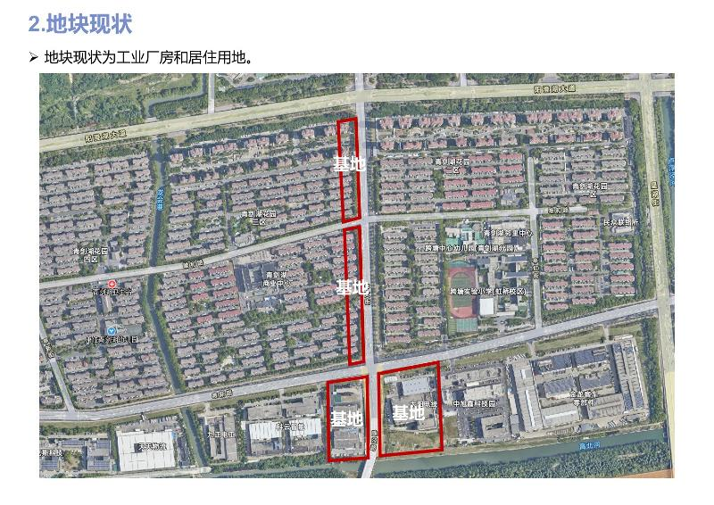](http://2.46.5.112:8004/website-webapp/common/preview_resource.action?id=eea9d05eaaaf4148a4a590949362d291%26type=jpg%26jcrVer=1.0)  
  
[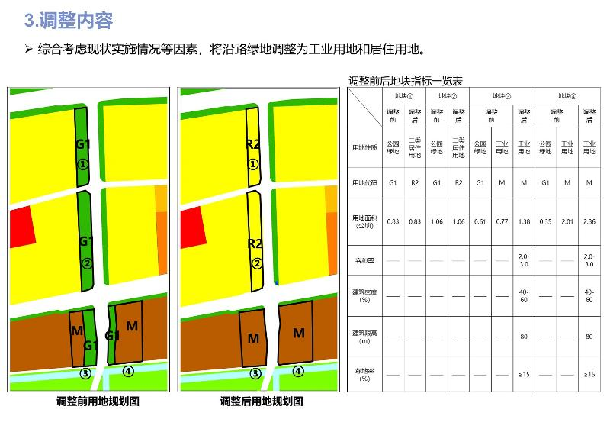](http://2.46.5.112:8004/website-webapp/common/preview_resource.action?id=1c09d4c74fa146818a051a44447dbade%26type=jpg%26jcrVer=1.0)  
  
  
  
[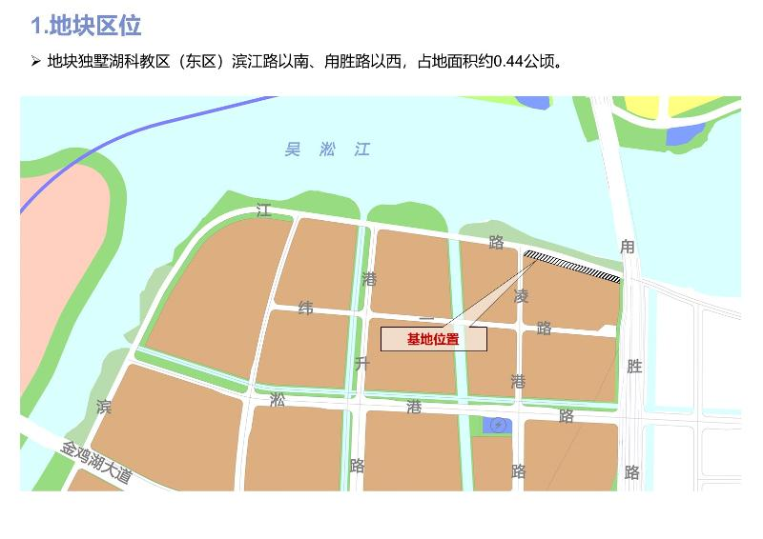](http://2.46.5.112:8004/website-webapp/common/preview_resource.action?id=18bdc2c7c5ed431ab8d5d2854fcba47d%26type=jpg%26jcrVer=1.0)  
  
[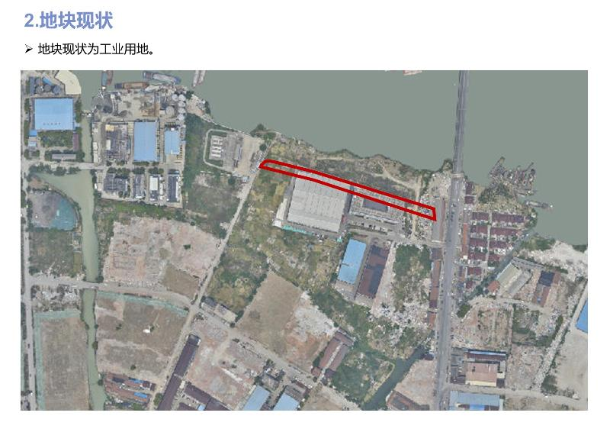](http://2.46.5.112:8004/website-webapp/common/preview_resource.action?id=7ca1547dee9a4560ae10de8e1f36a9d2%26type=jpg%26jcrVer=1.0)  
  
[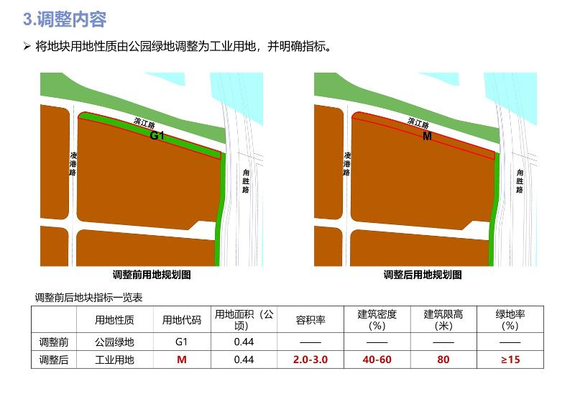](http://2.46.5.112:8004/website-webapp/common/preview_resource.action?id=53fb21066d2e45abb01defbe9593a6c2%26type=jpg%26jcrVer=1.0)  
  
  
  
[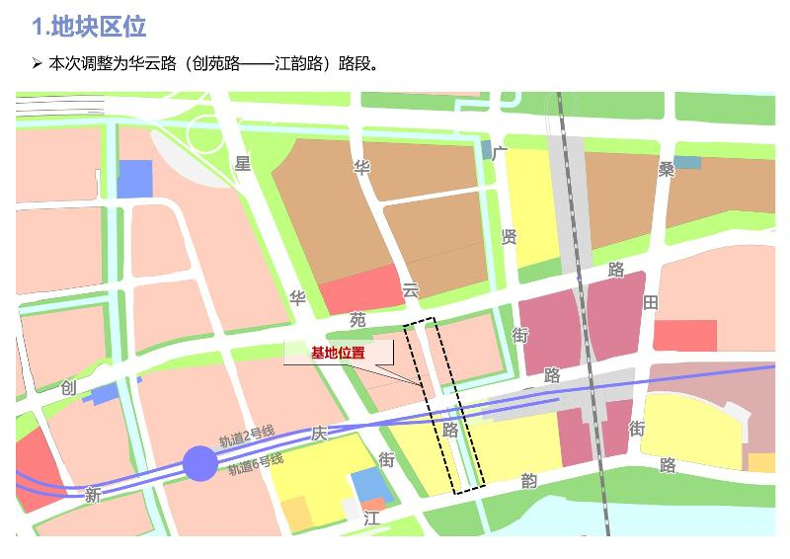](http://2.46.5.112:8004/website-webapp/common/preview_resource.action?id=658d14d7c62741ea9e2f8cbce79d8313%26type=jpg%26jcrVer=1.0)  
  
[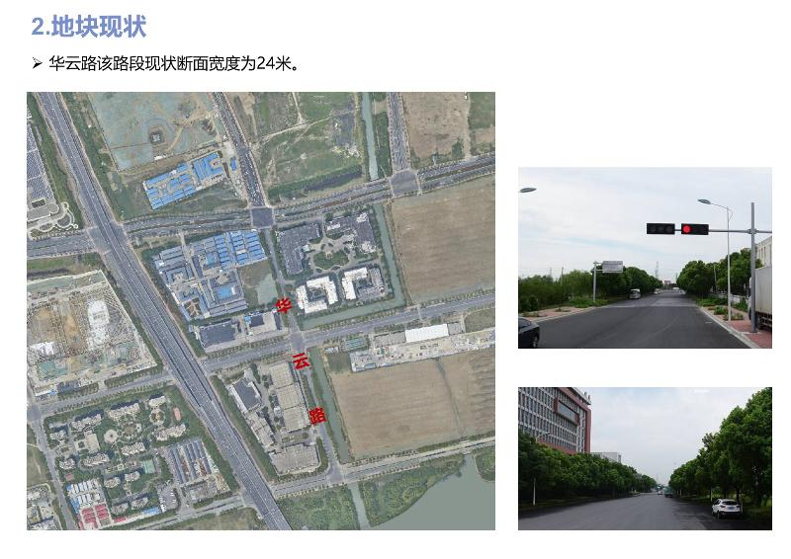](http://2.46.5.112:8004/website-webapp/common/preview_resource.action?id=aed53bbe2e0943de907c344bb701dc3a%26type=jpg%26jcrVer=1.0)  
  
[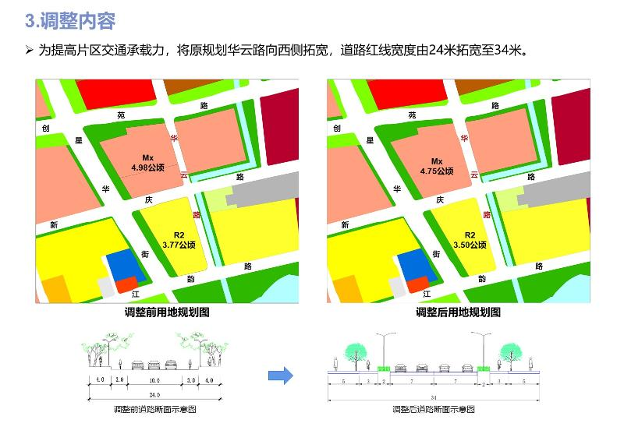](http://2.46.5.112:8004/website-webapp/common/preview_resource.action?id=36f8b391b2bb4df78300cd1ead9aadb7%26type=jpg%26jcrVer=1.0)  
  
  
  
[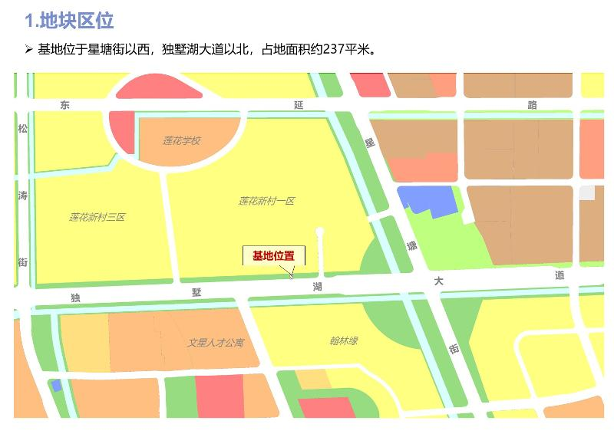](http://2.46.5.112:8004/website-webapp/common/preview_resource.action?id=5c360bfa01d64d538269db95abdad763%26type=jpg%26jcrVer=1.0)  
  
[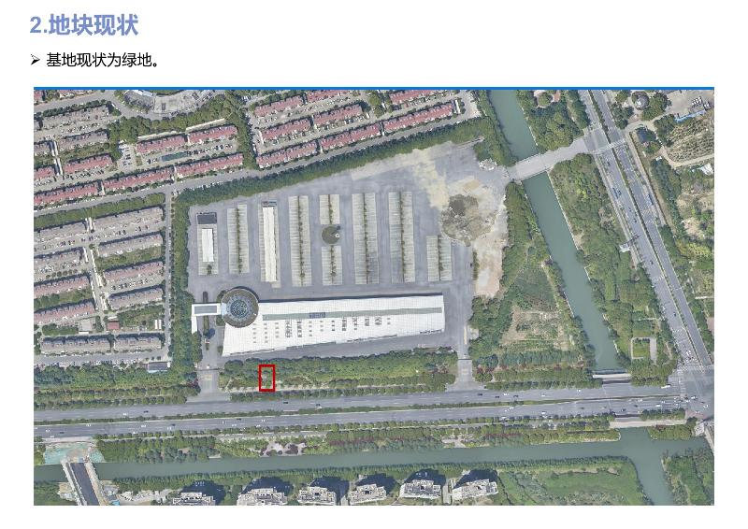](http://2.46.5.112:8004/website-webapp/common/preview_resource.action?id=ba15061ee67d4378910717616c708ee8%26type=jpg%26jcrVer=1.0)  
  
[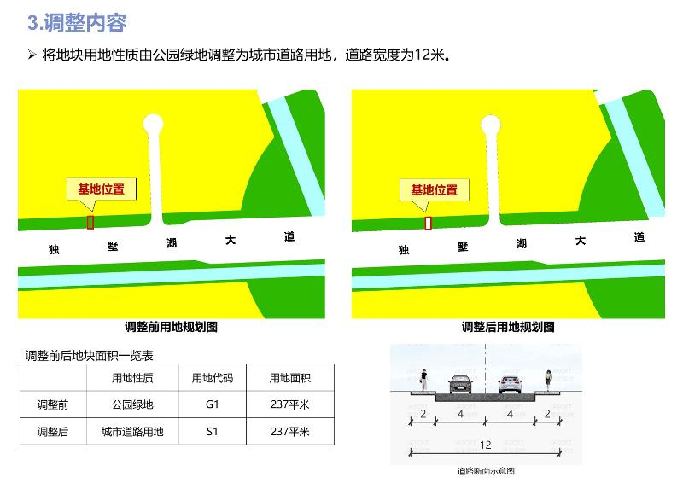](http://2.46.5.112:8004/website-webapp/common/preview_resource.action?id=888e94b580a74fcdb6cf22e1e1b744ce%26type=jpg%26jcrVer=1.0)  
  
  
  
[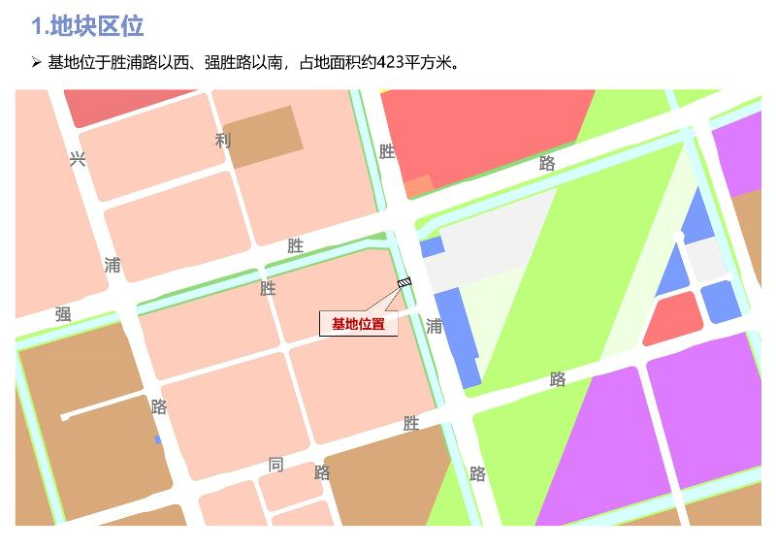](http://2.46.5.112:8004/website-webapp/common/preview_resource.action?id=1bf8518338124efe92eaeef8d3e048fa%26type=jpg%26jcrVer=1.0)  
  
[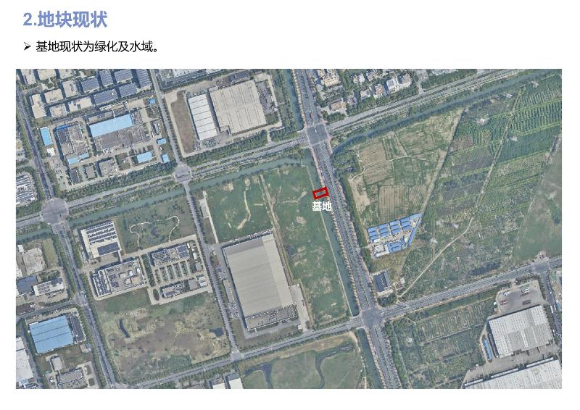](http://2.46.5.112:8004/website-webapp/common/preview_resource.action?id=f1f76134c5e74120a0437bc52059162c%26type=jpg%26jcrVer=1.0)  
  
[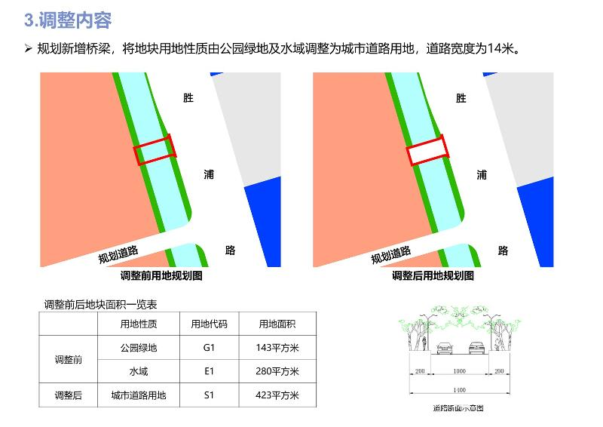](http://2.46.5.112:8004/website-webapp/common/preview_resource.action?id=08e86f848b1743b5b9e0e2d97a2be501%26type=jpg%26jcrVer=1.0)  
  
  
  
[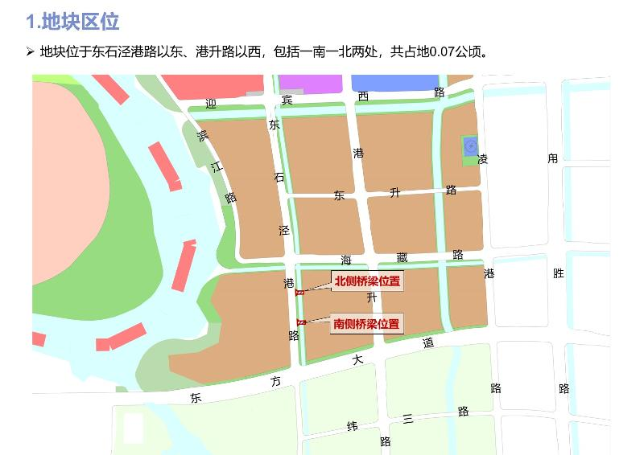](http://2.46.5.112:8004/website-webapp/common/preview_resource.action?id=dfb06267cf074e249589342de4e2bffe%26type=jpg%26jcrVer=1.0)  
  
[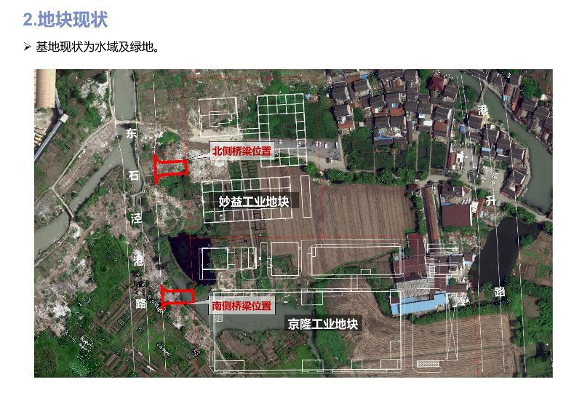](http://2.46.5.112:8004/website-webapp/common/preview_resource.action?id=96cab90f4c6a47ffaa43d7a818aaf710%26type=jpg%26jcrVer=1.0)  
  
[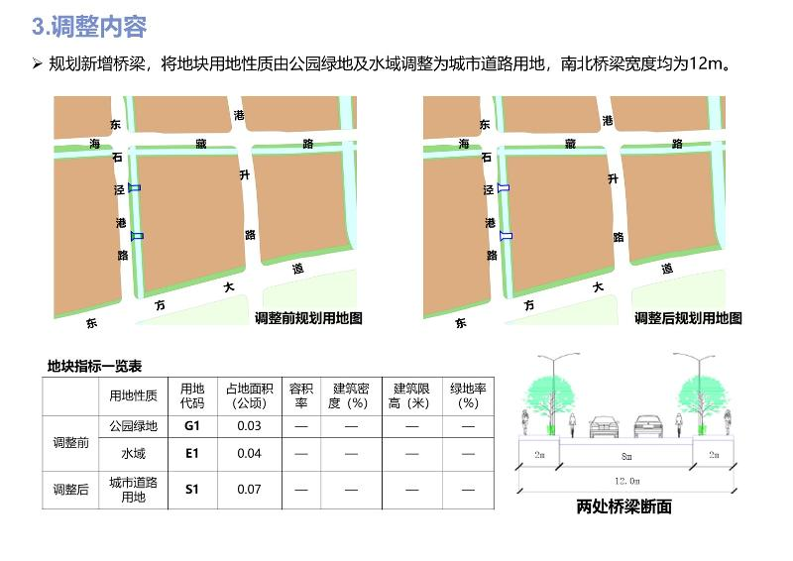](http://2.46.5.112:8004/website-webapp/common/preview_resource.action?id=254e6fb01e5d4afeb95f698d36104950%26type=jpg%26jcrVer=1.0)  
  
  
  
[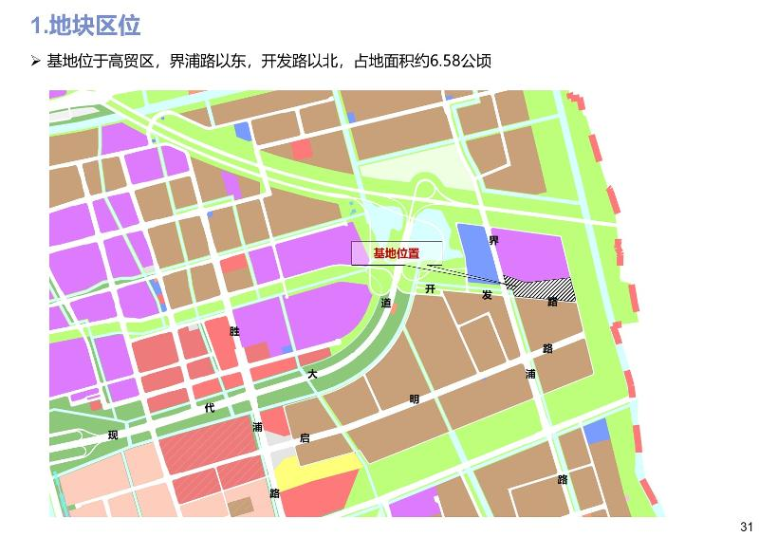](http://2.46.5.112:8004/website-webapp/common/preview_resource.action?id=ad7a96a886ca4bc29bfb7c4d2c07897a%26type=jpg%26jcrVer=1.0)  
  
[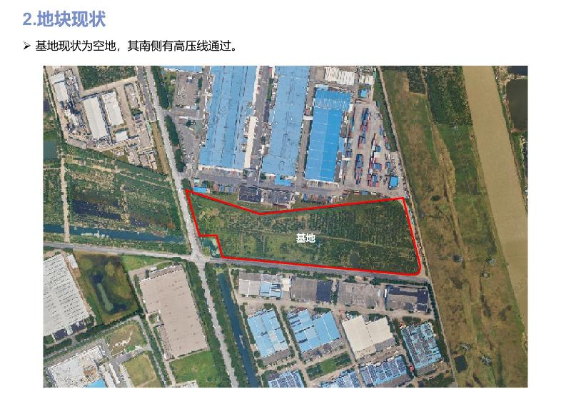](http://2.46.5.112:8004/website-webapp/common/preview_resource.action?id=f0e13a128ded4d15b3e61911b612797e%26type=jpg%26jcrVer=1.0)  
  
[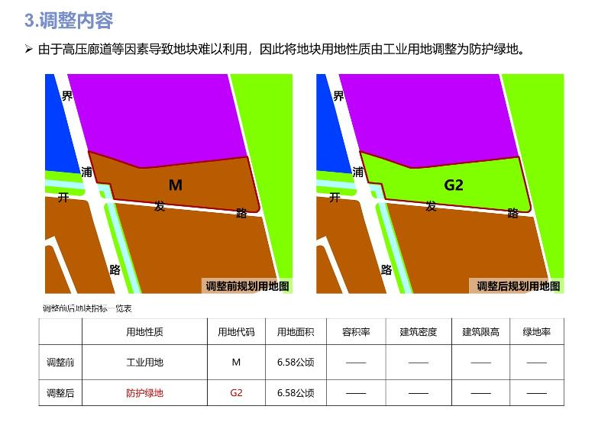](http://2.46.5.112:8004/website-webapp/common/preview_resource.action?id=419b84ca718744b093f26d73f150a086%26type=jpg%26jcrVer=1.0)